Task 0: Explain what you are doing/ going to accomplish

I’m trying to allow the user to input test choices and to submit it and get a score and the answers outputted to them.

Note:

For the beginning on this version, I was drawing blanks in what I needed to do. So, I have finally got something kind of working. Not sure if it’s the best way, buts it’s the only way I can come up with.

Task 1: Sketch interface design

*Draft a rough design for the interface that allows the user to trigger functionality in task 1, while also annotating where the information in task 2 will be displayed. Create another sketch listing the interface widgets used to create the interface.*

Task 2: Identify any classes required

*Explain what the class will represent, plus listing what information will be stored in the class and any functions the class will have.*

Task 3: Identify information to be displayed

*What information will the interface need to display to the user?*

It would have to output the amount of answers correct and what was the correct answers

Task 4: Identify user inputs

*What program functions can the user trigger through the interface?*

4 buttons to choose from for each question

Task 5: Identify any constants or existing data if required

Task 6: Identify indexed data structures

Task 7: Determine what calculations are necessary

*Write out the calculations the program will have to compute.*

Add together the amount of correct choices

Task 8: Develop a modular structure for your program

*Describe any functions that the computer program will have, identifying any sub-functions where required.*

Task 9: Define the functions identified

*Describe the functions for both the main program and any classes in terms of input and/or output where required. You may choose to do this with flow charts or pseudo-code (not Python code!). Add in additional steps or explanations using sequential, conditional, iterative statements where required. Identify global and/or local variables.*

V1

Request input from question 1 and set as user’s choice 1

Request input from question 2 and set as user’s choice 2

Etc…

For answer in Questions (class)

If user’s choice (1,2,…) equals correct answers

set Questions.correct to 1

V2

For questions in test_list

set user’s choice to requested forms (questions’s id) get from quiz.html

if user’s choice equal to questions’s answers

add 1 to total answers

Task 10: Address any relevant implications such as usability, functionality, legal/ethical requirements.

I added more comments to help future people

After looking at my website, I think I should change the colour scheme, something about orange and black seems to be off. I’ll get someone to have a look at and give suggesting

Task 11: Document test cases for testing the program

*Document any testing that can be used to test your program. If any input is inputted using the keyboard, describe the expected input, plus any exceptional, boundary or invalid cases.*

When finished with the quiz, it should show the amount the user got correct and

Task 12: Refine the plan

*Note any modifications here when iterating through the development cycles.*

V1

Didn’t work, quickly figured out I’m asking to a viable in a list that doesn’t exist

V2

The correct answers show but it won’t show the amount of right choices. Now I’m going to set each question to their own page and include it on the quiz page.

Task 13: Document testing

*Show screenshots of your program working with descriptions of each image. These images should test the tests cases listed above.*

 V2 : not showing the right amount of correct answers, always 0.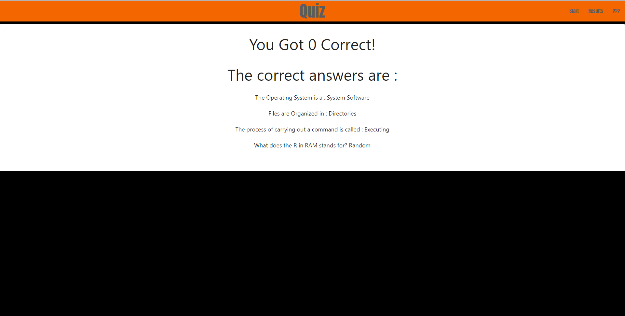

Task 14 : Evaluation

*How did your version turn out*